Exploring Religious Differences in Online vs. In-Person Worship Attendance During COVID-19
Author: Tingji Tao, Kamron, Jizhou
Course: MSSP Consulting Project
Client: Tyler Fuller (Department of Religion)
Date: 2025/11/28

Abstract
This study investigates how U.S. Catholics and Protestants differed in their worship attendance patterns—online, in-person, or both—during the COVID-19 pandemic, specifically before vaccines became widely available. Using the Pew Research Center’s American Trends Panel (ATP), we analyze survey responses collected in July 2020 (Wave 70) and March 2021 (Wave 84). Exploratory data analysis summarizes denominational, demographic, and attitudinal differences. Multinomial logistic regression models are developed to identify predictors of online versus in-person attendance, including demographic and Health Belief Model–related variables.
This project focuses on comparing Catholics and Protestants, two of the largest Christian groups in the U.S., analyzing differences in:
Online religious service attendance
In-person worship participation
Hybrid (both online and in-person) behavior
The goal is to understand whether denominational affiliation shapes worship decisions under public health constraints, and which demographic or belief-related factors predict online worship.

2. Background and Project Description
The project has three major components: project goals, data source, and experiment design.

2.1 Project Goals
Determine online vs. in-person religious attendance rates among U.S. Catholics and Protestants.
Identify predictors of online worship participation.
Compare denominational differences at two time points:
Wave 70 (July 2020)—early pandemic
Wave 84 (March 2021)—during vaccine rollout
Provide insights to inform public health communication strategies during future crises.

2.2 Data Source
Survey collected through Pew Research Center’s American Trends Panel (ATP).
Nationally representative, probability-based sample (~10,000 panelists).
Conducted via telephone interviews.
Uses standard Pew methodology for weighting and design.

2.3 Relevant Concepts
Health Belief Model (HBM): explains behavior based on perceived risk, benefit, barriers, and cues to action.
ATP: a multimode panel providing high-quality U.S. public opinion data.
Additional factors such as religious importance, pastor communication, and perceived COVID threat may act as behavioral triggers.

3. Data Description
This dataset includes approximately 6,000 Catholic and Protestant respondents across Waves 70 and 84. Variables available include:

3.1 Demographic Variables
-Age
-Gender
-Race/Ethnicity
-Education
-Income
-Region & Metro Area
-Political ideology

3.2 Religion & Worship Variables
Religious tradition (Catholic / Protestant)
Self-reported attendance frequency
Online service participation
In-person service participation
Congregation streaming availability

3.3 Health Belief Model Variables
Perceived COVID threat
COVID confidence
Social cues (religious importance, communication frequency)

3.4 Data Cleaning Steps (to be filled by you later)
You will summarize:
How missing values were handled
How the attendance outcome (“Both”, “In-person only”, “Online only”) was constructed
How the religion variable was cleaned and filtered
How the two waves were combined or analyzed separately
(Leave space for your description.)

4. Exploratory Data Analysis (EDA)

Part 1: Overall Attendance Distribution
Insert barplots or summary tables comparing:
% Online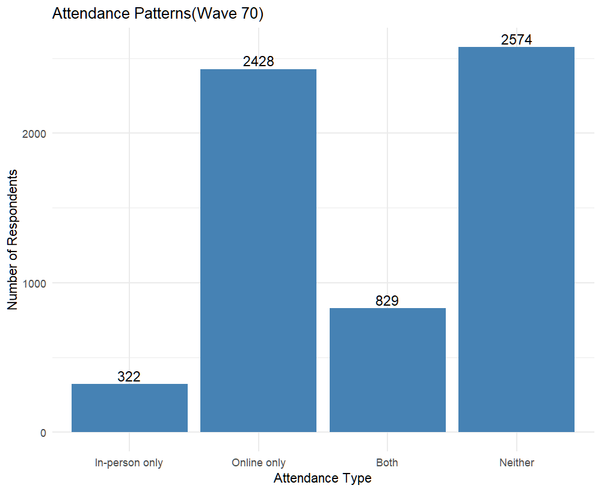
% In-person
% Both
# R code for attendance distribution plots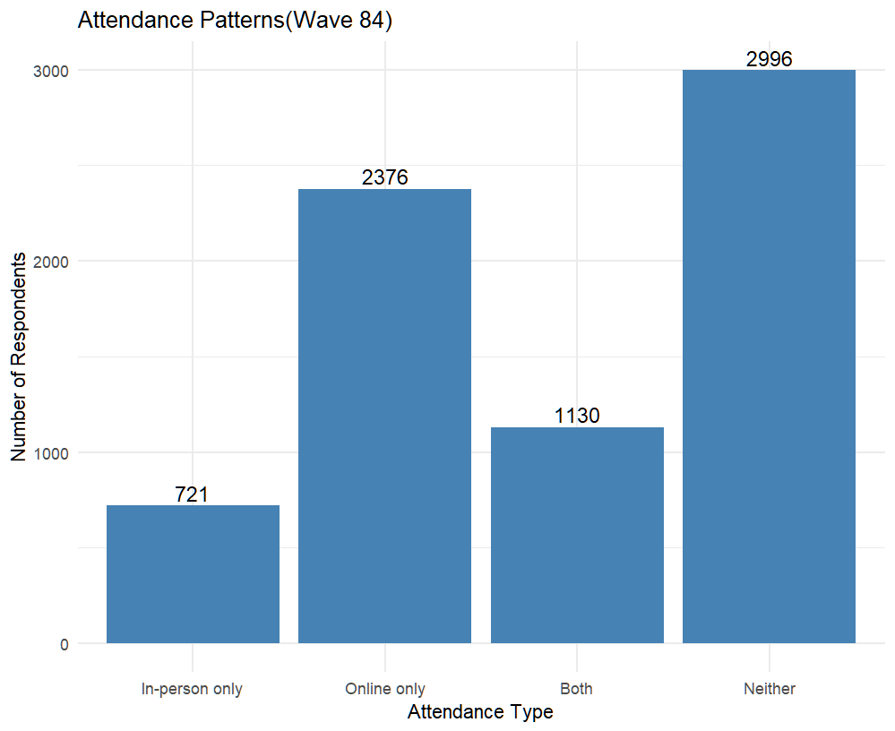

Part 2: Comparison by Religion
Include:
Boxplots / barplots
Wave 70 vs Wave 84 comparison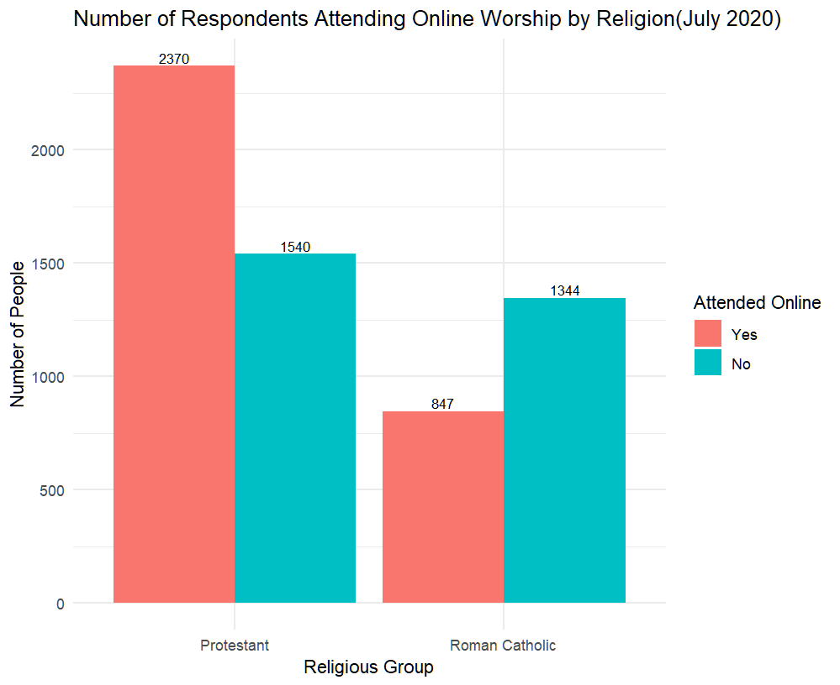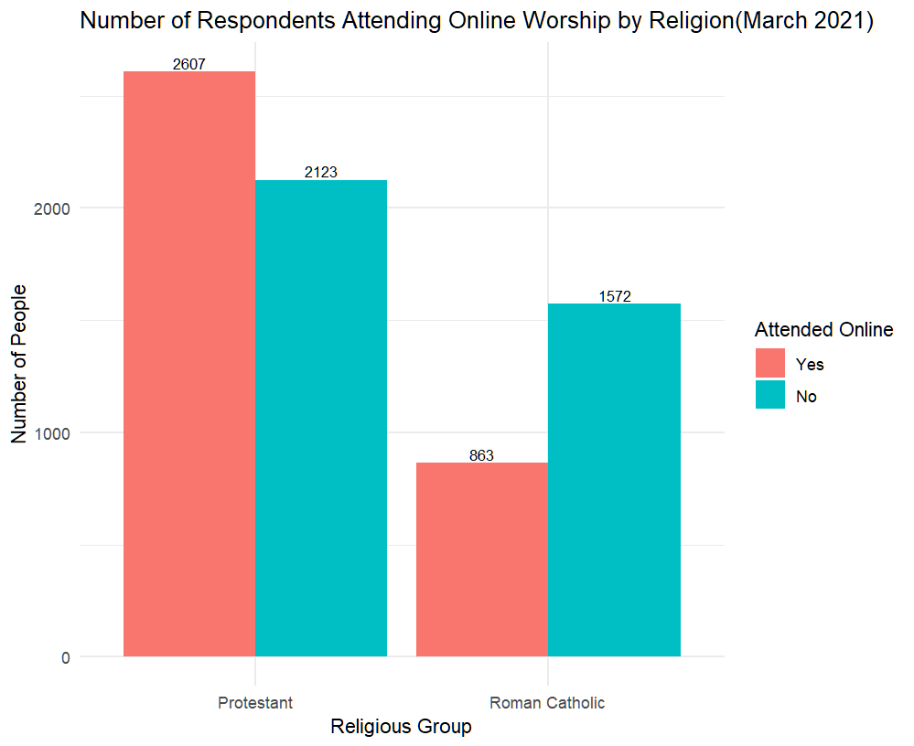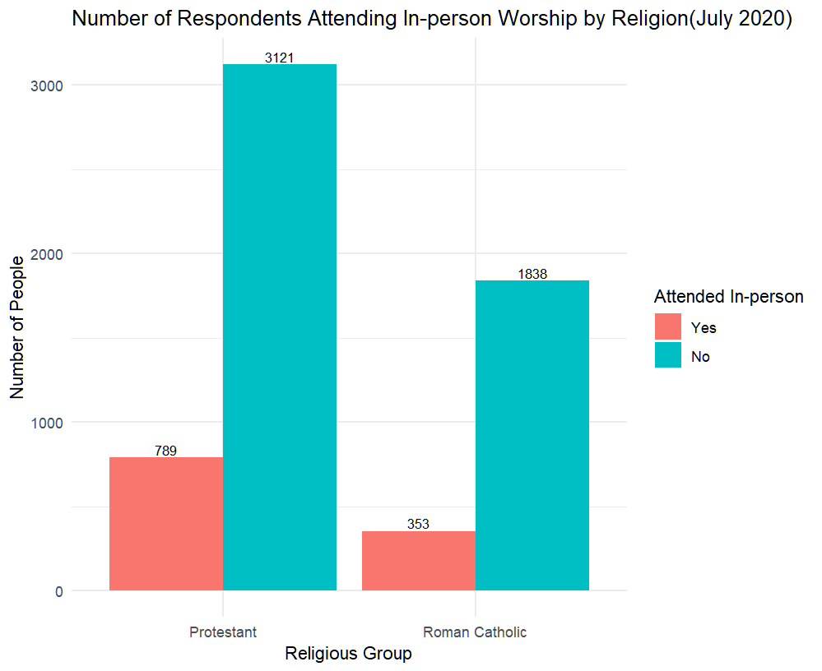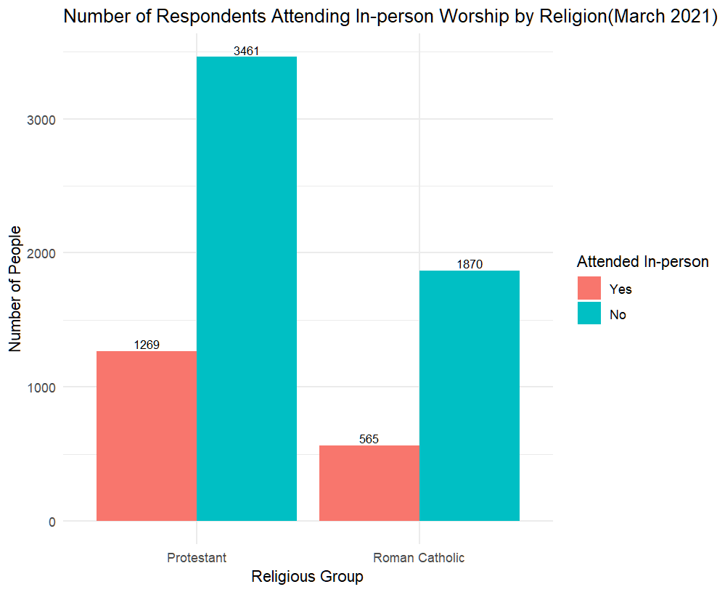
# R code for Catholic vs Protestant comparisons

Part 3: Demographic Patterns
Tables summarizing demographic characteristics by religion and attendance type.
(Leave blank)
# demographic summary table code

Part 4: HBM Variables
Plots for:
Perceived threat

Confidence

Congregation streaming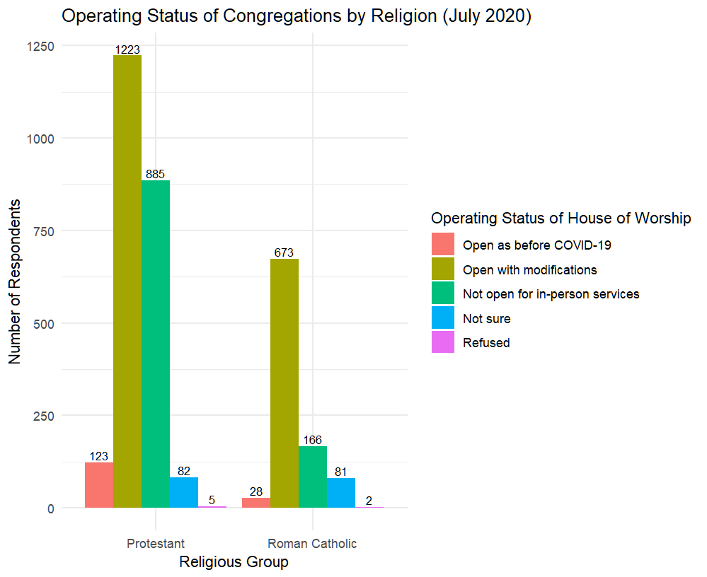

(Leave blank)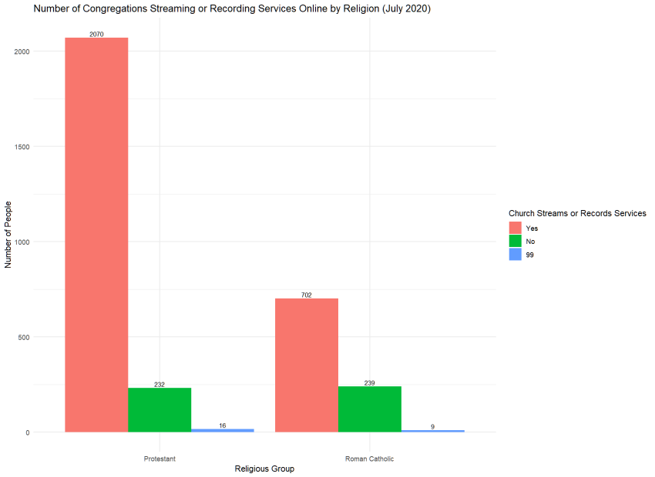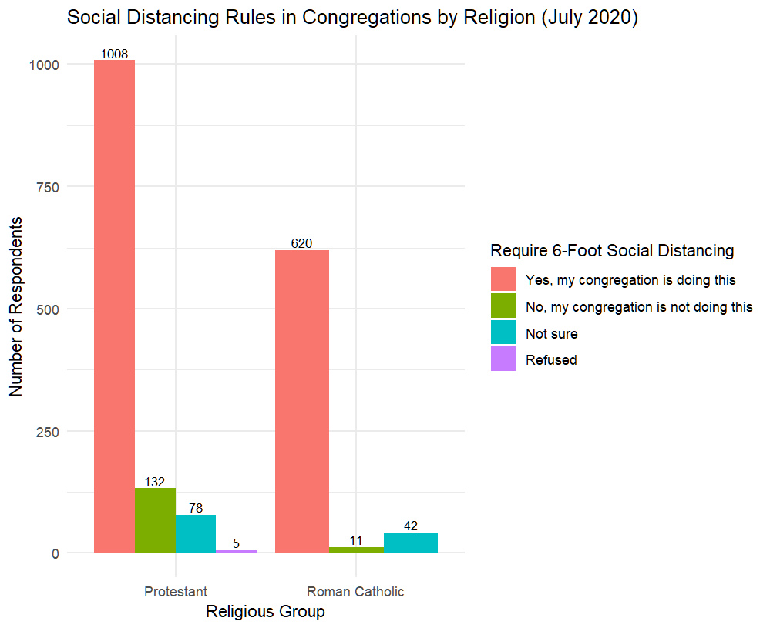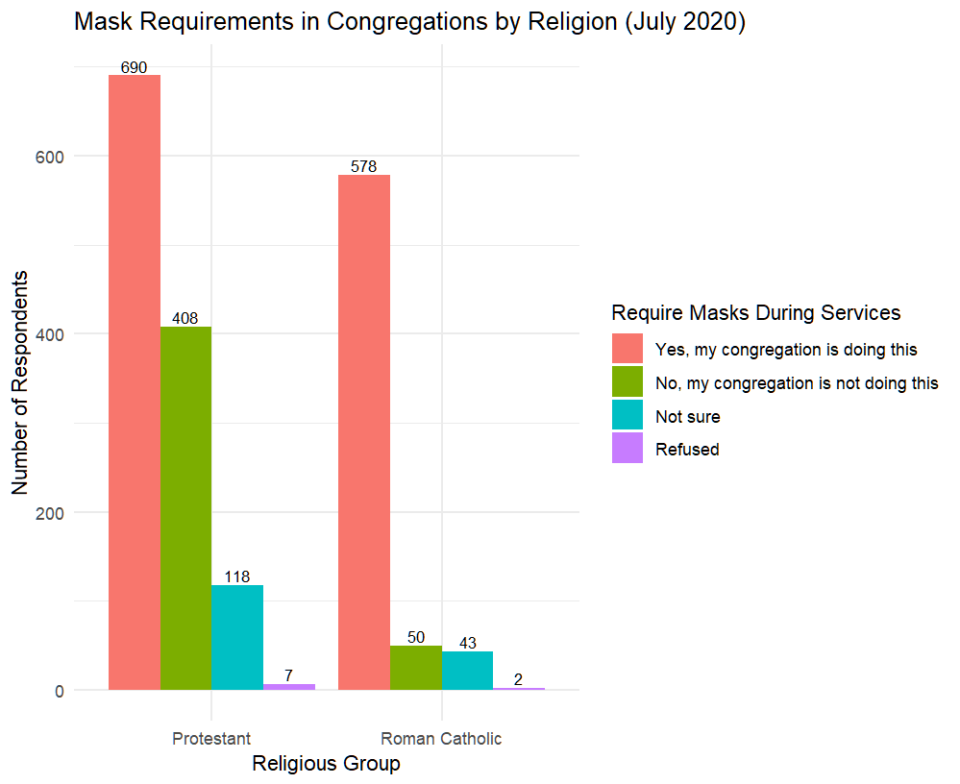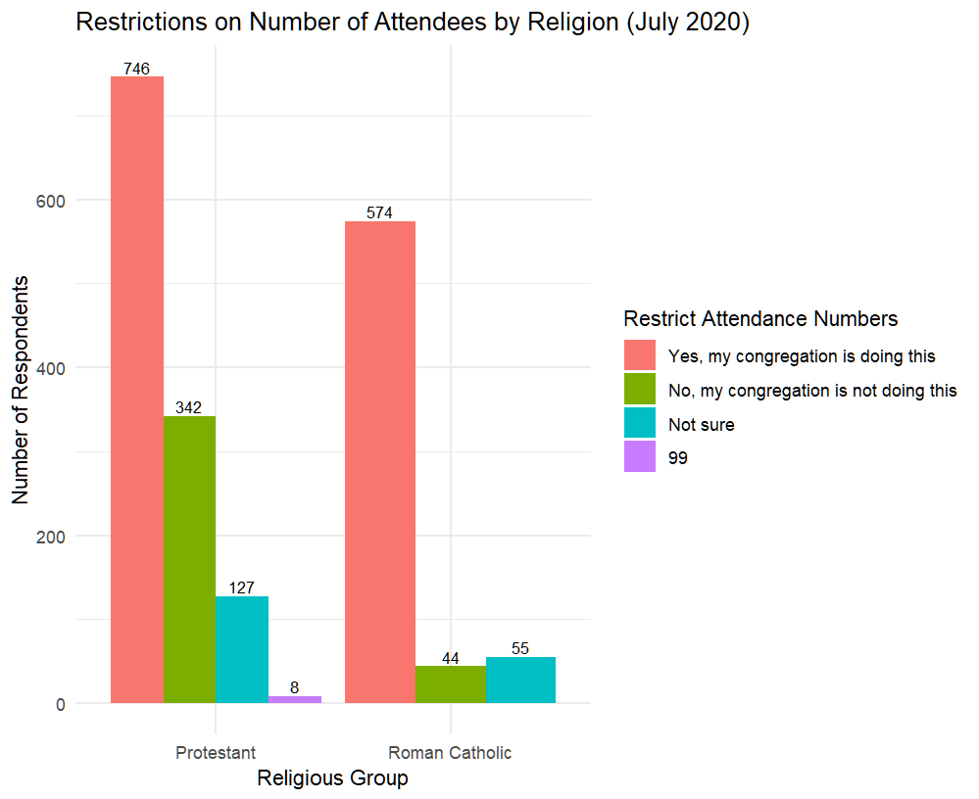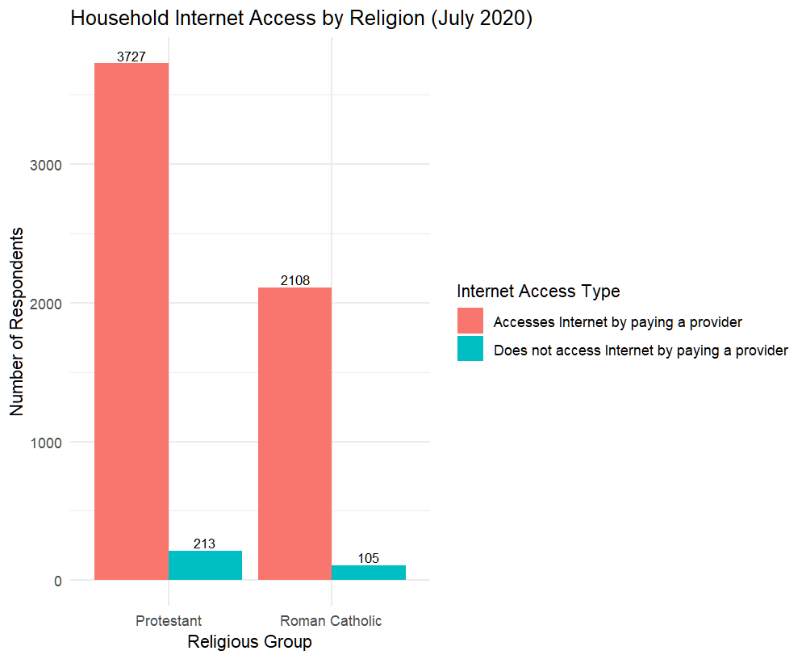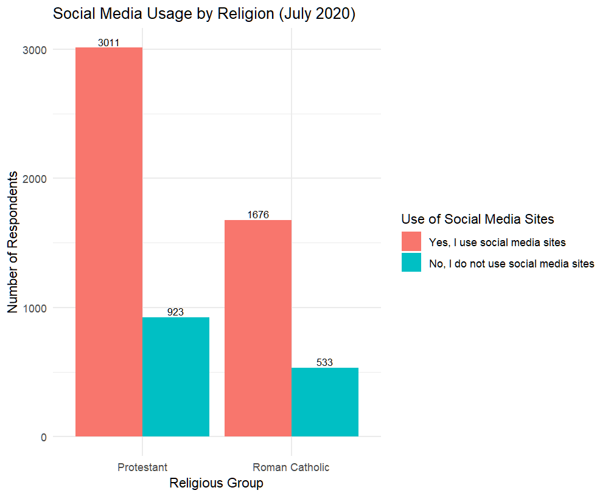
# HBM-related EDA

5. Modeling

5.1 Model Specification
Outcome variable:

attend ∈ {inperson, online, both}

Main predictor:

religion ∈ {Catholic, Protestant}

Controls may include:

age, gender, education, political ideology

COVID beliefs (perceived threat, confidence)

streaming availability

internet access

Model form (to be inserted after you choose):
model <- multinom(attend ~ religion + age + gender + ..., data = ...)

5.2 Model Versions
Model 1 — Religion only
(code placeholder)
Model 2 — Add demographics
(code placeholder)
Model 3 — Add HBM variables
(code placeholder)
Model Comparison Table
(leave blank)
Model | Predictors | AIC | Pseudo-R2 | Notes
1 | Religion only | ___ | ___ | ___
2 | + Demographics | ___ | ___ | ___
3 | + HBM variables | ___ | ___ | chosen

6. Results

6.1 Model Output
Paste your summary(modelX) output here later:
# summary(model3)

6.2 Interpretation
Leave space for interpretation of key coefficients:

Religion effect

Age effect

HBM predictors

Wave comparison

(You will fill these once the results are known.)

7. Discussion
To be filled after results:

Did Catholics attend online more than Protestants?

Did Protestants return in person faster?

Which demographic factors mattered most?

How do HBM variables influence attendance decisions?

(Leave blank)

8. Conclusion
Summarize:

Main denominational differences

Implications for public health communication

Future analysis directions (Bayesian models, random effects)

(Leave blank)

9. Appendix
Include:

Diagnostic plots

R code

Full tables
(Leave space.)

# Step 1: 清除含有 99 的观测
w70_cp_clean <- w70_cp %>%
filter(if_all(c(
ATTENDCONF_W70, COVIDCONG3_W70, COVIDCONG4_W70,
CONGRESTRICT2_a_W70, CONGRESTRICT2_b_W70, CONGRESTRICT2_c_W70,
CTKNOW1_W70, CONTACTTRAC1_W70,
SERMONISSUE_a_W70, SERMONISSUE_b_W70, SERMONISSUE_c_W70,
SERMONISSUE_d_W70, SERMONISSUE_e_W70, SERMONISSUE_f_W70
), ~ . != 99))
# Step 2: 转为 factor
w70_cp_clean <- w70_cp_clean %>%
mutate(across(c(
ATTENDCONF_W70, COVIDCONG3_W70, COVIDCONG4_W70,
CONGRESTRICT2_a_W70, CONGRESTRICT2_b_W70, CONGRESTRICT2_c_W70,
CTKNOW1_W70, CONTACTTRAC1_W70,
SERMONISSUE_a_W70, SERMONISSUE_b_W70, SERMONISSUE_c_W70,
SERMONISSUE_d_W70, SERMONISSUE_e_W70, SERMONISSUE_f_W70
), as.factor))
# Step 3: 设置 reference 类别
w70_cp_clean$attend <- relevel(w70_cp_clean$attend, ref = "In-person only")
# Step 4: 自动检测并移除只有一个水平的变量
vars_h1 <- c(
"ATTENDCONF_W70", "COVIDCONG3_W70", "COVIDCONG4_W70",
"CONGRESTRICT2_a_W70", "CONGRESTRICT2_b_W70", "CONGRESTRICT2_c_W70",
"CTKNOW1_W70", "CONTACTTRAC1_W70",
"SERMONISSUE_a_W70", "SERMONISSUE_b_W70", "SERMONISSUE_c_W70",
"SERMONISSUE_d_W70", "SERMONISSUE_e_W70", "SERMONISSUE_f_W70"
)
# 检查每个变量的水平数
level_counts <- sapply(w70_cp_clean[, vars_h1], nlevels)
invalid_vars <- names(level_counts[level_counts <= 1])
if (length(invalid_vars) > 0) {
message("⚠️ 以下变量只有一个水平，被自动移除: ", paste(invalid_vars, collapse = ", "))
}
⚠️ 以下变量只有一个水平，被自动移除: COVIDCONG4_W70
valid_vars <- setdiff(vars_h1, invalid_vars)
# Step 5: 动态建立 formula
formula_h1 <- as.formula(paste("attend ~", paste(valid_vars, collapse = " + ")))
# Step 6: 拟合模型
model_h1 <- multinom(formula_h1, data = w70_cp_clean)
Warning in multinom(formula_h1, data = w70_cp_clean): group 'Neither' is empty
# weights: 66 (42 variable)
initial value 1789.639418
iter 10 value 1423.418449
iter 20 value 1342.390197
iter 30 value 1334.129807
iter 40 value 1333.722167
iter 50 value 1333.705863
final value 1333.705846
converged
# Step 7: 输出 summary 与显著性
summary(model_h1)
Call:
multinom(formula = formula_h1, data = w70_cp_clean)
Coefficients:
(Intercept) ATTENDCONF_W702 ATTENDCONF_W703 ATTENDCONF_W704
Online only -0.7199058 0.6715364 2.17852703 3.455312
Both 1.3796340 -0.3211065 0.02906243 1.046654
COVIDCONG3_W702 COVIDCONG3_W703 COVIDCONG3_W704
Online only 1.0628470 2.9654929 0.7155992
Both 0.2844887 0.1414456 -1.3295144
CONGRESTRICT2_a_W702 CONGRESTRICT2_b_W702 CONGRESTRICT2_c_W702
Online only -0.08536717 -0.3353494 -0.6545903
Both 0.21114385 0.3191209 -0.4675444
CTKNOW1_W702 CTKNOW1_W703 CTKNOW1_W704 CONTACTTRAC1_W702
Online only -0.1142149 0.3545167 -0.20555358 0.4277780
Both 0.1563127 0.0882134 0.07929013 0.1623047
CONTACTTRAC1_W703 SERMONISSUE_a_W702 SERMONISSUE_b_W702
Online only 0.7112632 0.3894031 -0.009003079
Both 0.3794154 0.3089964 -0.169780048
SERMONISSUE_c_W702 SERMONISSUE_d_W702 SERMONISSUE_e_W702
Online only -0.5720430 -0.080421877 0.01729502
Both -0.5974311 0.001647749 -0.28322188
SERMONISSUE_f_W702
Online only -0.1315571
Both -0.7423866
Std. Errors:
(Intercept) ATTENDCONF_W702 ATTENDCONF_W703 ATTENDCONF_W704
Online only 0.5678765 0.1781822 0.3436311 1.027228
Both 0.5110312 0.1751887 0.3712603 1.075746
COVIDCONG3_W702 COVIDCONG3_W703 COVIDCONG3_W704
Online only 0.4737798 0.5573023 0.6366466
Both 0.4212390 0.5364591 0.7104233
CONGRESTRICT2_a_W702 CONGRESTRICT2_b_W702 CONGRESTRICT2_c_W702
Online only 0.3155999 0.2322300 0.2070422
Both 0.2862459 0.2176004 0.2005571
CTKNOW1_W702 CTKNOW1_W703 CTKNOW1_W704 CONTACTTRAC1_W702
Online only 0.1965213 0.2873707 0.2850843 0.2110419
Both 0.1953927 0.2917858 0.2817153 0.2060415
CONTACTTRAC1_W703 SERMONISSUE_a_W702 SERMONISSUE_b_W702
Online only 0.3405476 0.2725667 0.2109429
Both 0.3361204 0.2630449 0.2082300
SERMONISSUE_c_W702 SERMONISSUE_d_W702 SERMONISSUE_e_W702
Online only 0.2010535 0.2522052 0.2264868
Both 0.1991021 0.2441884 0.2221476
SERMONISSUE_f_W702
Online only 0.1882797
Both 0.1833581
Residual Deviance: 2667.412
AIC: 2751.412
# check p-values to find statstical significant variables
tidy(model_h1, conf.int = TRUE) %>% print(n = 42)
# A tibble: 42 × 8
y.level term estimate std.error statistic p.value conf.low conf.high
<chr> <chr> <dbl> <dbl> <dbl> <dbl> <dbl> <dbl>
1 Online only (Interc… -0.720 0.568 -1.27 2.05e- 1 -1.83 0.393
2 Online only ATTENDC… 0.672 0.178 3.77 1.64e- 4 0.322 1.02
3 Online only ATTENDC… 2.18 0.344 6.34 2.30e-10 1.51 2.85
4 Online only ATTENDC… 3.46 1.03 3.36 7.69e- 4 1.44 5.47
5 Online only COVIDCO… 1.06 0.474 2.24 2.49e- 2 0.134 1.99
6 Online only COVIDCO… 2.97 0.557 5.32 1.03e- 7 1.87 4.06
7 Online only COVIDCO… 0.716 0.637 1.12 2.61e- 1 -0.532 1.96
8 Online only CONGRES… -0.0854 0.316 -0.270 7.87e- 1 -0.704 0.533
9 Online only CONGRES… -0.335 0.232 -1.44 1.49e- 1 -0.791 0.120
10 Online only CONGRES… -0.655 0.207 -3.16 1.57e- 3 -1.06 -0.249
11 Online only CTKNOW1… -0.114 0.197 -0.581 5.61e- 1 -0.499 0.271
12 Online only CTKNOW1… 0.355 0.287 1.23 2.17e- 1 -0.209 0.918
13 Online only CTKNOW1… -0.206 0.285 -0.721 4.71e- 1 -0.764 0.353
14 Online only CONTACT… 0.428 0.211 2.03 4.27e- 2 0.0141 0.841
15 Online only CONTACT… 0.711 0.341 2.09 3.67e- 2 0.0438 1.38
16 Online only SERMONI… 0.389 0.273 1.43 1.53e- 1 -0.145 0.924
17 Online only SERMONI… -0.00900 0.211 -0.0427 9.66e- 1 -0.422 0.404
18 Online only SERMONI… -0.572 0.201 -2.85 4.44e- 3 -0.966 -0.178
19 Online only SERMONI… -0.0804 0.252 -0.319 7.50e- 1 -0.575 0.414
20 Online only SERMONI… 0.0173 0.226 0.0764 9.39e- 1 -0.427 0.461
21 Online only SERMONI… -0.132 0.188 -0.699 4.85e- 1 -0.501 0.237
22 Both (Interc… 1.38 0.511 2.70 6.94e- 3 0.378 2.38
23 Both ATTENDC… -0.321 0.175 -1.83 6.68e- 2 -0.664 0.0223
24 Both ATTENDC… 0.0291 0.371 0.0783 9.38e- 1 -0.699 0.757
25 Both ATTENDC… 1.05 1.08 0.973 3.31e- 1 -1.06 3.16
26 Both COVIDCO… 0.284 0.421 0.675 4.99e- 1 -0.541 1.11
27 Both COVIDCO… 0.141 0.536 0.264 7.92e- 1 -0.910 1.19
28 Both COVIDCO… -1.33 0.710 -1.87 6.13e- 2 -2.72 0.0629
29 Both CONGRES… 0.211 0.286 0.738 4.61e- 1 -0.350 0.772
30 Both CONGRES… 0.319 0.218 1.47 1.42e- 1 -0.107 0.746
31 Both CONGRES… -0.468 0.201 -2.33 1.97e- 2 -0.861 -0.0745
32 Both CTKNOW1… 0.156 0.195 0.800 4.24e- 1 -0.227 0.539
33 Both CTKNOW1… 0.0882 0.292 0.302 7.62e- 1 -0.484 0.660
34 Both CTKNOW1… 0.0793 0.282 0.281 7.78e- 1 -0.473 0.631
35 Both CONTACT… 0.162 0.206 0.788 4.31e- 1 -0.242 0.566
36 Both CONTACT… 0.379 0.336 1.13 2.59e- 1 -0.279 1.04
37 Both SERMONI… 0.309 0.263 1.17 2.40e- 1 -0.207 0.825
38 Both SERMONI… -0.170 0.208 -0.815 4.15e- 1 -0.578 0.238
39 Both SERMONI… -0.597 0.199 -3.00 2.69e- 3 -0.988 -0.207
40 Both SERMONI… 0.00165 0.244 0.00675 9.95e- 1 -0.477 0.480
41 Both SERMONI… -0.283 0.222 -1.27 2.02e- 1 -0.719 0.152
42 Both SERMONI… -0.742 0.183 -4.05 5.15e- 5 -1.10 -0.383
library(dplyr)
library(nnet)
library(gtsummary)
w70_h1 <- w70_cp_clean %>%
mutate(
# 1️⃣ 出席信心
ATTENDCONF_W70 = factor(
ATTENDCONF_W70,
levels = c(1, 2, 3, 4),
labels = c("Very confident",
"Somewhat confident",
"Not too confident",
"Not at all confident")
),
# 2️⃣ 教会防疫行动
COVIDCONG3_W70 = factor(
COVIDCONG3_W70,
levels = c(1, 2, 3, 4),
labels = c("No actions",
"Some actions",
"Many actions",
"Extensive actions")
),
# 3️⃣ 教会限制措施
CONGRESTRICT2_c_W70 = factor(
CONGRESTRICT2_c_W70,
levels = c(1, 2, 3, 4),
labels = c("No restrictions",
"Minor restrictions",
"Major restrictions",
"Severe restrictions")
),
# 4️⃣ 接触追踪
CONTACTTRAC1_W70 = factor(
CONTACTTRAC1_W70,
levels = c(1, 2),
labels = c("Support contact tracing",
"Do not support")
),
# 5️⃣ 布道主题 c: COVID 防控
SERMONISSUE_c_W70 = factor(
SERMONISSUE_c_W70,
levels = c(1, 2),
labels = c("Heard sermons on limiting COVID spread",
"Did not hear such sermons")
),
# 6️⃣ 布道主题 f: 其他议题
SERMONISSUE_f_W70 = factor(
SERMONISSUE_f_W70,
levels = c(1, 2),
labels = c("Heard sermons on other topics",
"Did not hear such sermons")
)
)
#set "did not hear" as reference
w70_h1$SERMONISSUE_c_W70 <- relevel(
w70_h1$SERMONISSUE_c_W70,
ref = "Did not hear such sermons"
)
w70_h1$SERMONISSUE_f_W70 <- relevel(
w70_h1$SERMONISSUE_f_W70,
ref = "Did not hear such sermons"
)
w70_h1$CONTACTTRAC1_W70 <- relevel(
w70_h1$CONTACTTRAC1_W70,
ref = "Do not support"
)
model_h1_sub <- multinom(
attend ~ ATTENDCONF_W70 + COVIDCONG3_W70 +
CONGRESTRICT2_c_W70 + CONTACTTRAC1_W70 +
SERMONISSUE_c_W70 + SERMONISSUE_f_W70,
data = w70_h1
)
Warning in multinom(attend ~ ATTENDCONF_W70 + COVIDCONG3_W70 +
CONGRESTRICT2_c_W70 + : group 'Neither' is empty
# weights: 42 (26 variable)
initial value 1610.565615
iter 10 value 1249.831906
iter 20 value 1224.451627
final value 1223.978562
converged
tbl_regression(
model_h1_sub,
exponentiate = TRUE,
label = list(
ATTENDCONF_W70 ~ "Confidence in attending safely",
COVIDCONG3_W70 ~ "Congregation’s COVID safety actions",
CONGRESTRICT2_c_W70 ~ "Congregational restrictions",
CONTACTTRAC1_W70 ~ "Contact tracing support",
SERMONISSUE_c_W70 ~ "Sermon topic: limiting COVID spread",
SERMONISSUE_f_W70 ~ "Sermon topic: other issues"
)
) %>%
modify_caption("**Predictors of Online and Hybrid Attendance (Refused Responses Removed)**") %>%
bold_labels()
ℹ Multinomial models, multi-component models and other groups models have a
different underlying structure than the models gtsummary was designed for.
• Functions designed to work with `tbl_regression()` objects may yield
unexpected results.
ℹ Suppress this message with `?suppressMessages()`.
Characteristic | OR | 95% CI | p-value
Online only
Confidence in attending safely
Very confident | — | —
Somewhat confident | 1.94 | 1.35, 2.79 | <0.001
Not too confident | 9.31 | 4.62, 18.8 | <0.001
Not at all confident | 29.0 | 3.83, 220 | 0.001
Congregation’s COVID safety actions
No actions | — | —
Some actions | 2.57 | 0.93, 7.06 | 0.068
Many actions | 16.7 | 5.14, 54.1 | <0.001
Extensive actions | 2.33 | 0.60, 9.04 | 0.2
Congregational restrictions
No restrictions | — | —
Minor restrictions | 0.47 | 0.33, 0.69 | <0.001
Major restrictions | 1.00 | 1.00, 1.00 | >0.9
Severe restrictions | 1.00 | 1.00, 1.00 | >0.9
Contact tracing support
Do not support | — | —
Support contact tracing | 0.65 | 0.43, 0.98 | 0.039
Sermon topic: limiting COVID spread
Did not hear such sermons | — | —
Heard sermons on limiting COVID spread | 1.76 | 1.20, 2.59 | 0.004
Sermon topic: other issues
Did not hear such sermons | — | —
Heard sermons on other topics | 1.13 | 0.78, 1.63 | 0.5
Both
Confidence in attending safely
Very confident | — | —
Somewhat confident | 0.70 | 0.49, 0.99 | 0.046
Not too confident | 0.89 | 0.41, 1.91 | 0.8
Not at all confident | 2.82 | 0.34, 23.3 | 0.3
Congregation’s COVID safety actions
No actions | — | —
Some actions | 1.41 | 0.56, 3.54 | 0.5
Many actions | 1.33 | 0.42, 4.17 | 0.6
Extensive actions | 0.30 | 0.06, 1.42 | 0.13
Congregational restrictions
No restrictions | — | —
Minor restrictions | 0.68 | 0.48, 0.98 | 0.039
Major restrictions | 1.00 | 1.00, 1.00
Severe restrictions | 1.00 | 1.00, 1.00
Contact tracing support
Do not support | — | —
Support contact tracing | 0.86 | 0.58, 1.28 | 0.5
Sermon topic: limiting COVID spread
Did not hear such sermons | — | —
Heard sermons on limiting COVID spread | 1.83 | 1.25, 2.68 | 0.002
Sermon topic: other issues
Did not hear such sermons | — | —
Heard sermons on other topics | 2.16 | 1.51, 3.10 | <0.001
Abbreviations: CI = Confidence Interval, OR = Odds Ratio
# Step 1: 清理掉含有 99 的观测
w70_cp_clean <- w70_cp %>%
filter(if_all(c(
COVIDTHREAT_a_W70, COVIDTHREAT_b_W70, COVIDTHREAT_c_W70,
SERMONISSUE_a_W70, SERMONISSUE_b_W70, SERMONISSUE_c_W70,
SERMONISSUE_d_W70, SERMONISSUE_e_W70, SERMONISSUE_f_W70,
COVIDLESSON1_W70, COVIDLESSON2_W70,
CONGRESTRICT2_a_W70, CONGRESTRICT2_b_W70, CONGRESTRICT2_c_W70,
COVIDCONG4_W70
), ~ . != 99))
# Step 2: 将所有自变量转为因子
w70_cp_clean <- w70_cp_clean %>%
mutate(across(c(
COVIDTHREAT_a_W70, COVIDTHREAT_b_W70, COVIDTHREAT_c_W70,
SERMONISSUE_a_W70, SERMONISSUE_b_W70, SERMONISSUE_c_W70,
SERMONISSUE_d_W70, SERMONISSUE_e_W70, SERMONISSUE_f_W70,
COVIDLESSON1_W70, COVIDLESSON2_W70,
CONGRESTRICT2_a_W70, CONGRESTRICT2_b_W70, CONGRESTRICT2_c_W70,
COVIDCONG4_W70
), as.factor))
# Step 3: 设置 reference 类别为 In-person only
w70_cp_clean$attend <- relevel(w70_cp_clean$attend, ref = "In-person only")
# Step 4: 自动检测并移除只有一个水平的变量
vars_h2 <- c(
"COVIDTHREAT_a_W70", "COVIDTHREAT_b_W70", "COVIDTHREAT_c_W70",
"SERMONISSUE_a_W70", "SERMONISSUE_b_W70", "SERMONISSUE_c_W70",
"SERMONISSUE_d_W70", "SERMONISSUE_e_W70", "SERMONISSUE_f_W70",
"COVIDLESSON1_W70", "COVIDLESSON2_W70",
"CONGRESTRICT2_a_W70", "CONGRESTRICT2_b_W70", "CONGRESTRICT2_c_W70",
"COVIDCONG4_W70"
)
# 检查每个变量的水平数
level_counts <- sapply(w70_cp_clean[, vars_h2], nlevels)
invalid_vars <- names(level_counts[level_counts <= 1])
if (length(invalid_vars) > 0) {
message("⚠️ 以下变量只有一个水平，被自动移除: ", paste(invalid_vars, collapse = ", "))
}
⚠️ 以下变量只有一个水平，被自动移除: COVIDLESSON1_W70, COVIDCONG4_W70
valid_vars <- setdiff(vars_h2, invalid_vars)
# Step 5: 动态建立 formula
formula_h2 <- as.formula(paste("attend ~", paste(valid_vars, collapse = " + ")))
# Step 6: 拟合多项逻辑回归模型
model_h2 <- multinom(formula_h2, data = w70_cp_clean)
Warning in multinom(formula_h2, data = w70_cp_clean): group 'Neither' is empty
# weights: 57 (36 variable)
initial value 1621.551738
iter 10 value 1427.929117
iter 20 value 1360.229742
iter 30 value 1355.334161
iter 40 value 1355.034026
iter 50 value 1354.981978
final value 1354.981899
converged
# Step 7: 输出结果与显著性
summary(model_h2)
Call:
multinom(formula = formula_h2, data = w70_cp_clean)
Coefficients:
(Intercept) COVIDTHREAT_a_W702 COVIDTHREAT_a_W703
Online only 2.093307 -0.3045787 -0.4364010
Both 1.915513 -0.1863922 -0.0214079
COVIDTHREAT_b_W702 COVIDTHREAT_b_W703 COVIDTHREAT_c_W702
Online only -0.4500344 -0.1979547 0.04223921
Both -0.2586253 -0.1167738 0.03824178
COVIDTHREAT_c_W703 SERMONISSUE_a_W702 SERMONISSUE_b_W702
Online only 1.1987150 0.4637585 -0.00654076
Both 0.1452293 0.3624229 -0.09050472
SERMONISSUE_c_W702 SERMONISSUE_d_W702 SERMONISSUE_e_W702
Online only -0.5505399 0.0564213 -0.1502468
Both -0.7315853 0.1378831 -0.1697184
SERMONISSUE_f_W702 COVIDLESSON2_W702 COVIDLESSON2_W703
Online only -0.1129122 -0.5239118 10.06398
Both -0.6891540 -0.7392679 11.04211
CONGRESTRICT2_a_W702 CONGRESTRICT2_b_W702 CONGRESTRICT2_c_W702
Online only 0.1398514 -0.4122931 -0.6340664
Both 0.3088788 0.4388556 -0.4277250
Std. Errors:
(Intercept) COVIDTHREAT_a_W702 COVIDTHREAT_a_W703
Online only 0.2764635 0.2051028 0.6113844
Both 0.2818791 0.2139728 0.5923198
COVIDTHREAT_b_W702 COVIDTHREAT_b_W703 COVIDTHREAT_c_W702
Online only 0.2082076 0.3480478 0.2629420
Both 0.2189853 0.3565003 0.2705209
COVIDTHREAT_c_W703 SERMONISSUE_a_W702 SERMONISSUE_b_W702
Online only 1.129650 0.2688844 0.2136333
Both 1.219744 0.2733379 0.2204349
SERMONISSUE_c_W702 SERMONISSUE_d_W702 SERMONISSUE_e_W702
Online only 0.2050070 0.2476612 0.2261368
Both 0.2163484 0.2522863 0.2324565
SERMONISSUE_f_W702 COVIDLESSON2_W702 COVIDLESSON2_W703
Online only 0.1912435 0.1751878 0.4648125
Both 0.1950832 0.1841364 0.4648129
CONGRESTRICT2_a_W702 CONGRESTRICT2_b_W702 CONGRESTRICT2_c_W702
Online only 0.3381173 0.2521209 0.2116469
Both 0.3258516 0.2476644 0.2167460
Residual Deviance: 2709.964
AIC: 2781.964
z <- summary(model_h2)$coefficients / summary(model_h2)$standard.errors
p <- (1 - pnorm(abs(z), 0, 1)) * 2
round(p, 4)
(Intercept) COVIDTHREAT_a_W702 COVIDTHREAT_a_W703
Online only 0 0.1375 0.4754
Both 0 0.3837 0.9712
COVIDTHREAT_b_W702 COVIDTHREAT_b_W703 COVIDTHREAT_c_W702
Online only 0.0307 0.5695 0.8724
Both 0.2376 0.7432 0.8876
COVIDTHREAT_c_W703 SERMONISSUE_a_W702 SERMONISSUE_b_W702
Online only 0.2886 0.0846 0.9756
Both 0.9052 0.1849 0.6814
SERMONISSUE_c_W702 SERMONISSUE_d_W702 SERMONISSUE_e_W702
Online only 0.0072 0.8198 0.5064
Both 0.0007 0.5847 0.4653
SERMONISSUE_f_W702 COVIDLESSON2_W702 COVIDLESSON2_W703
Online only 0.5549 0.0028 0
Both 0.0004 0.0001 0
CONGRESTRICT2_a_W702 CONGRESTRICT2_b_W702 CONGRESTRICT2_c_W702
Online only 0.6792 0.1020 0.0027
Both 0.3432 0.0764 0.0485
# Step 1: 清除含有 99 的观测
w70_cp_clean <- w70_cp %>%
filter(if_all(c(
SNSUSE_W70, F_ACSWEB, ONLINESERV_W70,
F_EDUCCAT2, F_AGECAT, F_INCOME_RECODE
), ~ . != 99))
# Step 2: 将所有自变量转为因子
w70_cp_clean <- w70_cp_clean %>%
mutate(across(c(
SNSUSE_W70, F_ACSWEB, ONLINESERV_W70,
F_EDUCCAT2, F_AGECAT, F_INCOME_RECODE
), as.factor))
# Step 3: 设置 reference 类别
w70_cp_clean$attend <- relevel(w70_cp_clean$attend, ref = "In-person only")
# Step 4: 自动检测并移除只有一个水平的变量
vars_h3 <- c(
"SNSUSE_W70", "F_ACSWEB", "ONLINESERV_W70",
"F_EDUCCAT2", "F_AGECAT", "F_INCOME_RECODE"
)
# 检查每个变量的水平数
level_counts <- sapply(w70_cp_clean[, vars_h3], nlevels)
invalid_vars <- names(level_counts[level_counts <= 1])
if (length(invalid_vars) > 0) {
message("⚠️ 以下变量只有一个水平，被自动移除: ", paste(invalid_vars, collapse = ", "))
}
valid_vars <- setdiff(vars_h3, invalid_vars)
# Step 5: 动态建立 formula
formula_h3 <- as.formula(paste("attend ~", paste(valid_vars, collapse = " + ")))
# Step 6: 拟合多项逻辑回归模型
model_h3 <- multinom(formula_h3, data = w70_cp_clean)
Warning in multinom(formula_h3, data = w70_cp_clean): groups 'In-person only'
'Neither' are empty
# weights: 15 (14 variable)
initial value 2103.008546
iter 10 value 1753.901708
iter 20 value 1723.302396
iter 20 value 1723.302394
iter 20 value 1723.302394
final value 1723.302394
converged
# Step 7: 输出结果与显著性
summary(model_h3)
Call:
multinom(formula = formula_h3, data = w70_cp_clean)
Coefficients:
Values Std. Err.
(Intercept) -0.51270025 0.29232834
SNSUSE_W702 0.05205660 0.10179904
F_ACSWEB2 -0.01773272 0.19416951
ONLINESERV_W702 0.13489123 0.08804236
F_EDUCCAT22 -0.33525342 0.23843964
F_EDUCCAT23 -0.50572685 0.23338526
F_EDUCCAT24 -0.43168374 0.24986711
F_EDUCCAT25 -0.71542271 0.23568659
F_EDUCCAT26 -0.52312004 0.23884718
F_AGECAT2 -0.07302046 0.17734030
F_AGECAT3 -0.02282677 0.17546865
F_AGECAT4 0.05657920 0.17798276
F_INCOME_RECODE2 -0.07747481 0.09859777
F_INCOME_RECODE3 -0.36823029 0.12838903
Residual Deviance: 3446.605
AIC: 3474.605
z <- summary(model_h3)$coefficients / summary(model_h3)$standard.errors
p <- (1 - pnorm(abs(z), 0, 1)) * 2
round(p, 4)
(Intercept) SNSUSE_W702 F_ACSWEB2 ONLINESERV_W702
0.0795 0.6091 0.9272 0.1255
F_EDUCCAT22 F_EDUCCAT23 F_EDUCCAT24 F_EDUCCAT25
0.1597 0.0302 0.0841 0.0024
F_EDUCCAT26 F_AGECAT2 F_AGECAT3 F_AGECAT4
0.0285 0.6805 0.8965 0.7506
F_INCOME_RECODE2 F_INCOME_RECODE3
0.4320 0.0041
# Step 1: 清除含有 99 的观测
w70_cp_clean <- w70_cp %>%
filter(if_all(c(
ONLINESERV_W70,
F_ACSWEB,
COVIDCONG2_W70, COVIDCONG3_W70, COVIDCONG4_W70,
CONGDONATE_W70
), ~ . != 99))
# Step 2: 将所有自变量转为因子
w70_cp_clean <- w70_cp_clean %>%
mutate(across(c(
ONLINESERV_W70,
F_ACSWEB,
COVIDCONG2_W70, COVIDCONG3_W70, COVIDCONG4_W70,
CONGDONATE_W70
), as.factor))
# Step 3: 设置 reference 类别
w70_cp_clean$attend <- relevel(w70_cp_clean$attend, ref = "In-person only")
# Step 4: 自动检测并移除只有一个水平的变量
vars_h4 <- c(
"ONLINESERV_W70",
"F_ACSWEB",
"COVIDCONG2_W70", "COVIDCONG3_W70", "COVIDCONG4_W70",
"CONGDONATE_W70"
)
# 检查每个变量的水平数
level_counts <- sapply(w70_cp_clean[, vars_h4], nlevels)
invalid_vars <- names(level_counts[level_counts <= 1])
if (length(invalid_vars) > 0) {
message("⚠️ 以下变量只有一个水平，被自动移除: ", paste(invalid_vars, collapse = ", "))
}
valid_vars <- setdiff(vars_h4, invalid_vars)
# Step 5: 动态建立公式
formula_h4 <- as.formula(paste("attend ~", paste(valid_vars, collapse = " + ")))
# Step 6: 拟合多项逻辑回归模型
model_h4 <- multinom(formula_h4, data = w70_cp_clean)
Warning in multinom(formula_h4, data = w70_cp_clean): groups 'In-person only'
'Neither' are empty
# weights: 13 (12 variable)
initial value 1669.791558
iter 10 value 1259.733095
iter 20 value 1204.643757
iter 20 value 1204.643750
iter 20 value 1204.643750
final value 1204.643750
converged
# Step 7: 输出结果与显著性
summary(model_h4)
Call:
multinom(formula = formula_h4, data = w70_cp_clean)
Coefficients:
Values Std. Err.
(Intercept) 1.40030343 0.2794256
ONLINESERV_W702 -0.01081019 0.1055133
F_ACSWEB2 0.49757801 0.2317354
COVIDCONG2_W702 0.18385529 0.1773760
COVIDCONG3_W702 -0.32086530 0.2359695
COVIDCONG3_W703 -2.12671172 0.2666344
COVIDCONG3_W704 -1.75689544 0.4796771
COVIDCONG4_W702 -0.47837653 0.1581179
COVIDCONG4_W703 -1.68986878 0.2131113
CONGDONATE_W702 -1.30384636 0.1963172
CONGDONATE_W703 -0.49193394 0.1665560
CONGDONATE_W704 -1.88079964 0.2765062
Residual Deviance: 2409.287
AIC: 2433.287
z <- summary(model_h4)$coefficients / summary(model_h4)$standard.errors
p <- (1 - pnorm(abs(z), 0, 1)) * 2
round(p, 4)
(Intercept) ONLINESERV_W702 F_ACSWEB2 COVIDCONG2_W702 COVIDCONG3_W702
0.0000 0.9184 0.0318 0.3000 0.1739
COVIDCONG3_W703 COVIDCONG3_W704 COVIDCONG4_W702 COVIDCONG4_W703 CONGDONATE_W702
0.0000 0.0002 0.0025 0.0000 0.0000
CONGDONATE_W703 CONGDONATE_W704
0.0031 0.0000
# Step 1: 清除含有 99 的观测
w70_cp_clean <- w70_cp %>%
filter(if_all(c(
CONGDONATE_W70,
COVIDCONG4_W70, COVIDCONG3_W70, COVIDCONG2_W70,
CONGRESTRICT2_a_W70, CONGRESTRICT2_b_W70, CONGRESTRICT2_c_W70,
F_METRO
), ~ . != 99))
# Step 2: 将所有自变量转为因子
w70_cp_clean <- w70_cp_clean %>%
mutate(across(c(
CONGDONATE_W70,
COVIDCONG4_W70, COVIDCONG3_W70, COVIDCONG2_W70,
CONGRESTRICT2_a_W70, CONGRESTRICT2_b_W70, CONGRESTRICT2_c_W70,
F_METRO
), as.factor))
# Step 3: 设置 reference 类别
w70_cp_clean$attend <- relevel(w70_cp_clean$attend, ref = "In-person only")
# Step 4: 自动检测并移除只有一个水平的变量
vars_h5 <- c(
"CONGDONATE_W70",
"COVIDCONG4_W70", "COVIDCONG3_W70", "COVIDCONG2_W70",
"CONGRESTRICT2_a_W70", "CONGRESTRICT2_b_W70", "CONGRESTRICT2_c_W70",
"F_METRO"
)
# 检查每个变量的水平数
level_counts <- sapply(w70_cp_clean[, vars_h5], nlevels)
invalid_vars <- names(level_counts[level_counts <= 1])
if (length(invalid_vars) > 0) {
message("⚠️ 以下变量只有一个水平，被自动移除: ", paste(invalid_vars, collapse = ", "))
}
⚠️ 以下变量只有一个水平，被自动移除: COVIDCONG4_W70
valid_vars <- setdiff(vars_h5, invalid_vars)
# Step 5: 动态建立 formula
formula_h5 <- as.formula(paste("attend ~", paste(valid_vars, collapse = " + ")))
# Step 6: 拟合多项逻辑回归模型
model_h5 <- multinom(formula_h5, data = w70_cp_clean)
# weights: 52 (36 variable)
initial value 2595.143044
iter 10 value 2140.473867
iter 20 value 2027.429196
iter 30 value 2015.085057
iter 40 value 2014.885982
iter 40 value 2014.885965
iter 40 value 2014.885964
final value 2014.885964
converged
# Step 7: 输出结果与显著性
summary(model_h5)
Call:
multinom(formula = formula_h5, data = w70_cp_clean)
Coefficients:
(Intercept) CONGDONATE_W702 CONGDONATE_W703 CONGDONATE_W704
Online only 0.7235872 1.24505927 0.57273305 0.9546684
Both 1.5160804 -0.03779188 0.05550558 -0.9972306
Neither -1.4488177 2.06346687 1.13625409 2.2276121
COVIDCONG3_W702 COVIDCONG3_W703 COVIDCONG3_W704 COVIDCONG2_W702
Online only 0.3598276 2.282111 0.7174043 -1.5174958
Both -0.1084876 -0.167790 -0.9743934 -1.3618832
Neither 0.4250494 2.019627 1.8903892 -0.4186463
CONGRESTRICT2_a_W702 CONGRESTRICT2_b_W702 CONGRESTRICT2_c_W702
Online only -0.20008799 -0.5752231 -0.7754465
Both -0.03656094 0.3002452 -0.5264813
Neither -0.41457428 -0.7666672 -1.4403840
F_METRO2
Online only -0.60503260
Both -0.04349124
Neither -0.78507373
Std. Errors:
(Intercept) CONGDONATE_W702 CONGDONATE_W703 CONGDONATE_W704
Online only 0.5107750 0.3292934 0.2795211 0.3880820
Both 0.4785371 0.3215343 0.2586021 0.4338406
Neither 0.7471532 0.5169657 0.4838508 0.5552799
COVIDCONG3_W702 COVIDCONG3_W703 COVIDCONG3_W704 COVIDCONG2_W702
Online only 0.4436675 0.5358951 0.5997098 0.2052347
Both 0.4193056 0.5426694 0.7036596 0.2099120
Neither 0.5922855 0.6758489 0.7084202 0.2332564
CONGRESTRICT2_a_W702 CONGRESTRICT2_b_W702 CONGRESTRICT2_c_W702
Online only 0.3086718 0.2295393 0.2027068
Both 0.2813056 0.2154772 0.1993537
Neither 0.5213776 0.3491894 0.3057118
F_METRO2
Online only 0.2242767
Both 0.2097665
Neither 0.3219012
Residual Deviance: 4029.772
AIC: 4101.772
z <- summary(model_h5)$coefficients / summary(model_h5)$standard.errors
p <- (1 - pnorm(abs(z), 0, 1)) * 2
round(p, 4)
(Intercept) CONGDONATE_W702 CONGDONATE_W703 CONGDONATE_W704
Online only 0.1566 0.0002 0.0405 0.0139
Both 0.0015 0.9064 0.8301 0.0215
Neither 0.0525 0.0001 0.0189 0.0001
COVIDCONG3_W702 COVIDCONG3_W703 COVIDCONG3_W704 COVIDCONG2_W702
Online only 0.4173 0.0000 0.2316 0.0000
Both 0.7958 0.7572 0.1661 0.0000
Neither 0.4730 0.0028 0.0076 0.0727
CONGRESTRICT2_a_W702 CONGRESTRICT2_b_W702 CONGRESTRICT2_c_W702
Online only 0.5168 0.0122 0.0001
Both 0.8966 0.1635 0.0083
Neither 0.4265 0.0281 0.0000
F_METRO2
Online only 0.0070
Both 0.8358
Neither 0.0147
# Step 1: 清除含有 99 的观测
w70_cp_clean <- w70_cp %>%
filter(if_all(c(
CONGRESTRICT2_d_W70,
COVIDCONG4_W70, COVIDCONG3_W70,
CONGRESTRICT1_a_W70, CONGRESTRICT1_b_W70, CONGRESTRICT1_c_W70,
ATTENDCONF_W70
), ~ . != 99))
# Step 2: 将所有自变量转为因子
w70_cp_clean <- w70_cp_clean %>%
mutate(across(c(
CONGRESTRICT2_d_W70,
COVIDCONG4_W70, COVIDCONG3_W70,
CONGRESTRICT1_a_W70, CONGRESTRICT1_b_W70, CONGRESTRICT1_c_W70,
ATTENDCONF_W70
), as.factor))
# Step 3: 设置 reference 类别
w70_cp_clean$attend <- relevel(w70_cp_clean$attend, ref = "In-person only")
# Step 4: 自动检测并移除只有一个水平的变量
vars_h6 <- c(
"CONGRESTRICT2_d_W70",
"COVIDCONG4_W70", "COVIDCONG3_W70",
"CONGRESTRICT1_a_W70", "CONGRESTRICT1_b_W70", "CONGRESTRICT1_c_W70",
"ATTENDCONF_W70"
)
# 检查每个变量的水平数
level_counts <- sapply(w70_cp_clean[, vars_h6], nlevels)
invalid_vars <- names(level_counts[level_counts <= 1])
if (length(invalid_vars) > 0) {
message("⚠️ 以下变量只有一个水平，被自动移除: ", paste(invalid_vars, collapse = ", "))
}
⚠️ 以下变量只有一个水平，被自动移除: COVIDCONG4_W70, COVIDCONG3_W70
valid_vars <- setdiff(vars_h6, invalid_vars)
# Step 5: 动态建立 formula
formula_h6 <- as.formula(paste("attend ~", paste(valid_vars, collapse = " + ")))
# Step 6: 拟合多项逻辑回归模型
model_h6 <- multinom(formula_h6, data = w70_cp_clean)
# weights: 48 (33 variable)
initial value 2033.693828
iter 10 value 1621.794509
iter 20 value 1584.688372
iter 30 value 1581.226156
iter 40 value 1580.781092
iter 50 value 1580.769872
iter 50 value 1580.769864
iter 50 value 1580.769864
final value 1580.769864
converged
# Step 7: 输出结果与显著性
summary(model_h6)
Call:
multinom(formula = formula_h6, data = w70_cp_clean)
Coefficients:
(Intercept) CONGRESTRICT2_d_W702 CONGRESTRICT1_a_W702
Online only 0.6731116 -0.20501800 -0.65499137
Both 1.2681169 0.03006681 0.15268566
Neither -0.6021969 -0.66831943 -0.06176189
CONGRESTRICT1_a_W703 CONGRESTRICT1_b_W702 CONGRESTRICT1_b_W703
Online only 2.189271 -0.81183480 0.7532681
Both 1.462749 -0.06589429 -0.3600075
Neither 2.872355 -1.21573677 1.1813797
CONGRESTRICT1_c_W702 CONGRESTRICT1_c_W703 ATTENDCONF_W702
Online only -0.6469988 -0.31283589 0.8683659
Both -0.4255992 -0.60308541 -0.2268616
Neither -1.0640645 -0.07565171 0.8686917
ATTENDCONF_W703 ATTENDCONF_W704
Online only 2.7119168 15.03589
Both 0.4035001 11.19150
Neither 2.4773811 15.26691
Std. Errors:
(Intercept) CONGRESTRICT2_d_W702 CONGRESTRICT1_a_W702
Online only 0.1803000 0.1906482 0.3842774
Both 0.1665970 0.1821949 0.3026356
Neither 0.2545739 0.2603080 0.5780700
CONGRESTRICT1_a_W703 CONGRESTRICT1_b_W702 CONGRESTRICT1_b_W703
Online only 1.057851 0.2358375 0.4730123
Both 1.084617 0.2074616 0.5181546
Neither 1.087279 0.3869620 0.5293952
CONGRESTRICT1_c_W702 CONGRESTRICT1_c_W703 ATTENDCONF_W702
Online only 0.2428989 0.3645272 0.1902930
Both 0.2142188 0.3641424 0.1778196
Neither 0.4098697 0.4360311 0.2748932
ATTENDCONF_W703 ATTENDCONF_W704
Online only 0.4197603 0.2926448
Both 0.4369020 0.5010028
Neither 0.4842694 0.3398977
Residual Deviance: 3161.54
AIC: 3227.54
z <- summary(model_h6)$coefficients / summary(model_h6)$standard.errors
p <- (1 - pnorm(abs(z), 0, 1)) * 2
round(p, 4)
(Intercept) CONGRESTRICT2_d_W702 CONGRESTRICT1_a_W702
Online only 0.0002 0.2822 0.0883
Both 0.0000 0.8689 0.6139
Neither 0.0180 0.0102 0.9149
CONGRESTRICT1_a_W703 CONGRESTRICT1_b_W702 CONGRESTRICT1_b_W703
Online only 0.0385 0.0006 0.1113
Both 0.1775 0.7508 0.4872
Neither 0.0082 0.0017 0.0256
CONGRESTRICT1_c_W702 CONGRESTRICT1_c_W703 ATTENDCONF_W702
Online only 0.0077 0.3908 0.0000
Both 0.0470 0.0977 0.2020
Neither 0.0094 0.8623 0.0016
ATTENDCONF_W703 ATTENDCONF_W704
Online only 0.0000 0
Both 0.3557 0
Neither 0.0000 0
# Step 1: 清除含有 99 的观测
w70_cp_clean <- w70_cp %>%
filter(if_all(c(
SERMONISSUE_a_W70, SERMONISSUE_b_W70, SERMONISSUE_c_W70,
SERMONISSUE_d_W70, SERMONISSUE_e_W70, SERMONISSUE_f_W70,
CTKNOW1_W70, CONTACTTRAC1_W70,
COVIDLESSON1_W70, COVIDLESSON2_W70,
COVIDCONG3_W70, COVIDCONG4_W70, COVIDCONG2_W70
), ~ . != 99))
# Step 2: 将所有自变量转为因子
w70_cp_clean <- w70_cp_clean %>%
mutate(across(c(
SERMONISSUE_a_W70, SERMONISSUE_b_W70, SERMONISSUE_c_W70,
SERMONISSUE_d_W70, SERMONISSUE_e_W70, SERMONISSUE_f_W70,
CTKNOW1_W70, CONTACTTRAC1_W70,
COVIDLESSON1_W70, COVIDLESSON2_W70,
COVIDCONG3_W70, COVIDCONG4_W70, COVIDCONG2_W70
), as.factor))
# Step 3: 设置 reference 类别
w70_cp_clean$attend <- relevel(w70_cp_clean$attend, ref = "In-person only")
# Step 4: 自动检测并移除只有一个水平的变量
vars_h7 <- c(
"SERMONISSUE_a_W70", "SERMONISSUE_b_W70", "SERMONISSUE_c_W70",
"SERMONISSUE_d_W70", "SERMONISSUE_e_W70", "SERMONISSUE_f_W70",
"CTKNOW1_W70", "CONTACTTRAC1_W70",
"COVIDLESSON1_W70", "COVIDLESSON2_W70",
"COVIDCONG3_W70", "COVIDCONG4_W70", "COVIDCONG2_W70"
)
# 检查每个变量的水平数
level_counts <- sapply(w70_cp_clean[, vars_h7], nlevels)
invalid_vars <- names(level_counts[level_counts <= 1])
if (length(invalid_vars) > 0) {
message("⚠️ 以下变量只有一个水平，被自动移除: ", paste(invalid_vars, collapse = ", "))
}
⚠️ 以下变量只有一个水平，被自动移除: COVIDLESSON1_W70
valid_vars <- setdiff(vars_h7, invalid_vars)
# Step 5: 动态建立 formula
formula_h7 <- as.formula(paste("attend ~", paste(valid_vars, collapse = " + ")))
# Step 6: 拟合多项逻辑回归模型
model_h7 <- multinom(formula_h7, data = w70_cp_clean)
Warning in multinom(formula_h7, data = w70_cp_clean): group 'Neither' is empty
# weights: 63 (40 variable)
initial value 2615.795859
iter 10 value 1887.780332
iter 20 value 1776.177751
iter 30 value 1749.999437
iter 40 value 1748.987406
iter 50 value 1748.805589
final value 1748.800767
converged
# Step 7: 输出结果与显著性
summary(model_h7)
Call:
multinom(formula = formula_h7, data = w70_cp_clean)
Coefficients:
(Intercept) SERMONISSUE_a_W702 SERMONISSUE_b_W702
Online only 0.2101889 0.39973490 -0.2143187
Both 1.4937218 0.03185325 -0.1107338
SERMONISSUE_c_W702 SERMONISSUE_d_W702 SERMONISSUE_e_W702
Online only -0.6733655 0.2994515 -0.1965422
Both -0.6431849 0.2325167 -0.1962231
SERMONISSUE_f_W702 CTKNOW1_W702 CTKNOW1_W703 CTKNOW1_W704
Online only -0.04729891 -0.1923381 0.16401435 -0.23558110
Both -0.50985570 0.1457968 0.04922529 -0.02036899
CONTACTTRAC1_W702 CONTACTTRAC1_W703 COVIDLESSON2_W702
Online only 0.21555867 0.6970630 -0.3484093
Both -0.01897788 0.4679422 -0.6615518
COVIDLESSON2_W703 COVIDCONG3_W702 COVIDCONG3_W703 COVIDCONG3_W704
Online only 10.14385 0.4589587 2.3034222 1.026806
Both 11.18538 0.2223505 0.2664471 -0.837073
COVIDCONG4_W702 COVIDCONG4_W703 COVIDCONG2_W702
Online only 0.6459292 1.7690002 -1.340518
Both 0.2351667 0.2358611 -1.396626
Std. Errors:
(Intercept) SERMONISSUE_a_W702 SERMONISSUE_b_W702
Online only 0.3733896 0.2326244 0.1863420
Both 0.3494569 0.2330265 0.1910891
SERMONISSUE_c_W702 SERMONISSUE_d_W702 SERMONISSUE_e_W702
Online only 0.1782884 0.2094105 0.1975224
Both 0.1842188 0.2113884 0.2011987
SERMONISSUE_f_W702 CTKNOW1_W702 CTKNOW1_W703 CTKNOW1_W704
Online only 0.1688785 0.1730175 0.2586796 0.2570765
Both 0.1713508 0.1780157 0.2713688 0.2651344
CONTACTTRAC1_W702 CONTACTTRAC1_W703 COVIDLESSON2_W702
Online only 0.1895731 0.3095337 0.1539451
Both 0.1923342 0.3149168 0.1600047
COVIDLESSON2_W703 COVIDCONG3_W702 COVIDCONG3_W703 COVIDCONG3_W704
Online only 0.4761446 0.3054030 0.3824950 0.4765898
Both 0.4761448 0.2870866 0.3912178 0.5824702
COVIDCONG4_W702 COVIDCONG4_W703 COVIDCONG2_W702
Online only 0.2324430 0.3334245 0.1850507
Both 0.2253186 0.3562760 0.1960680
Residual Deviance: 3497.602
AIC: 3577.602
z <- summary(model_h7)$coefficients / summary(model_h7)$standard.errors
p <- (1 - pnorm(abs(z), 0, 1)) * 2
round(p, 4)
(Intercept) SERMONISSUE_a_W702 SERMONISSUE_b_W702
Online only 0.5735 0.0857 0.2501
Both 0.0000 0.8913 0.5623
SERMONISSUE_c_W702 SERMONISSUE_d_W702 SERMONISSUE_e_W702
Online only 2e-04 0.1527 0.3197
Both 5e-04 0.2714 0.3294
SERMONISSUE_f_W702 CTKNOW1_W702 CTKNOW1_W703 CTKNOW1_W704
Online only 0.7794 0.2663 0.5261 0.3595
Both 0.0029 0.4128 0.8561 0.9388
CONTACTTRAC1_W702 CONTACTTRAC1_W703 COVIDLESSON2_W702
Online only 0.2555 0.0243 0.0236
Both 0.9214 0.1373 0.0000
COVIDLESSON2_W703 COVIDCONG3_W702 COVIDCONG3_W703 COVIDCONG3_W704
Online only 0 0.1329 0.0000 0.0312
Both 0 0.4386 0.4958 0.1507
COVIDCONG4_W702 COVIDCONG4_W703 COVIDCONG2_W702
Online only 0.0055 0.000 0
Both 0.2966 0.508 0
# Step 1: 清理含有 99 的观测
w70_cp_clean <- w70_cp %>%
filter(if_all(c(
CONGDONATE_W70,
ATTENDCONF_W70,
COVIDTHREAT_a_W70, COVIDTHREAT_b_W70, COVIDTHREAT_c_W70,
CONGRESTRICT2_d_W70,
SERMONISSUE_a_W70, SERMONISSUE_b_W70, SERMONISSUE_c_W70,
SERMONISSUE_d_W70, SERMONISSUE_e_W70, SERMONISSUE_f_W70,
ONLINESERV_W70,
F_RELIG
), ~ . != 99))
# Step 2: 转为因子
w70_cp_clean <- w70_cp_clean %>%
mutate(across(c(
CONGDONATE_W70,
ATTENDCONF_W70,
COVIDTHREAT_a_W70, COVIDTHREAT_b_W70, COVIDTHREAT_c_W70,
CONGRESTRICT2_d_W70,
SERMONISSUE_a_W70, SERMONISSUE_b_W70, SERMONISSUE_c_W70,
SERMONISSUE_d_W70, SERMONISSUE_e_W70, SERMONISSUE_f_W70,
ONLINESERV_W70,
F_RELIG
), as.factor))
# Step 3: 设置 reference 类别
w70_cp_clean$attend <- relevel(w70_cp_clean$attend, ref = "In-person only")
# Step 4: 自动检测并移除只有一个水平的变量
vars_h8 <- c(
"CONGDONATE_W70",
"ATTENDCONF_W70",
"COVIDTHREAT_a_W70", "COVIDTHREAT_b_W70", "COVIDTHREAT_c_W70",
"CONGRESTRICT2_d_W70",
"SERMONISSUE_a_W70", "SERMONISSUE_b_W70", "SERMONISSUE_c_W70",
"SERMONISSUE_d_W70", "SERMONISSUE_e_W70", "SERMONISSUE_f_W70",
"ONLINESERV_W70",
"F_RELIG"
)
level_counts <- sapply(w70_cp_clean[, vars_h8], nlevels)
invalid_vars <- names(level_counts[level_counts <= 1])
if (length(invalid_vars) > 0) {
message("⚠️ 以下变量只有一个水平，被自动移除: ", paste(invalid_vars, collapse = ", "))
}
valid_vars <- setdiff(vars_h8, invalid_vars)
# Step 5: 动态 formula （带宗派交互项）
# 如果你想显式建模交互，可添加 "+ F_RELIG:CONGDONATE_W70" 等项
formula_h8 <- as.formula(paste("attend ~", paste(valid_vars, collapse = " + ")))
# Step 6: 拟合多项逻辑回归
model_h8 <- multinom(formula_h8, data = w70_cp_clean)
Warning in multinom(formula_h8, data = w70_cp_clean): groups 'In-person only'
'Neither' are empty
# weights: 23 (22 variable)
initial value 967.633464
iter 10 value 822.928637
iter 20 value 809.162477
final value 808.961799
converged
# Step 7: 输出结果与显著性
summary(model_h8)
Call:
multinom(formula = formula_h8, data = w70_cp_clean)
Coefficients:
Values Std. Err.
(Intercept) 1.017116073 0.2827876
CONGDONATE_W702 -0.902501003 0.2399026
CONGDONATE_W703 -0.182165139 0.2072131
CONGDONATE_W704 -1.466826145 0.3535918
ATTENDCONF_W702 -0.994708432 0.1356162
ATTENDCONF_W703 -2.038631938 0.2173432
ATTENDCONF_W704 -2.308654834 0.4057872
COVIDTHREAT_a_W702 -0.011637173 0.1521433
COVIDTHREAT_a_W703 0.003555273 0.4196994
COVIDTHREAT_b_W702 0.106107002 0.1481262
COVIDTHREAT_b_W703 -0.283733942 0.2390677
COVIDTHREAT_c_W702 0.006910769 0.1881679
COVIDTHREAT_c_W703 -0.905843904 0.7400497
CONGRESTRICT2_d_W702 0.333992280 0.1306965
SERMONISSUE_a_W702 -0.073480706 0.1959562
SERMONISSUE_b_W702 -0.070904468 0.1450338
SERMONISSUE_c_W702 0.063234839 0.1641635
SERMONISSUE_d_W702 0.126063622 0.1747801
SERMONISSUE_e_W702 -0.284219235 0.1539544
SERMONISSUE_f_W702 -0.602833953 0.1310388
ONLINESERV_W702 0.153390718 0.1335903
F_RELIG2 0.187310561 0.1418232
Residual Deviance: 1617.924
AIC: 1661.924
z <- summary(model_h8)$coefficients / summary(model_h8)$standard.errors
p <- (1 - pnorm(abs(z), 0, 1)) * 2
round(p, 4)
(Intercept) CONGDONATE_W702 CONGDONATE_W703
0.0003 0.0002 0.3793
CONGDONATE_W704 ATTENDCONF_W702 ATTENDCONF_W703
0.0000 0.0000 0.0000
ATTENDCONF_W704 COVIDTHREAT_a_W702 COVIDTHREAT_a_W703
0.0000 0.9390 0.9932
COVIDTHREAT_b_W702 COVIDTHREAT_b_W703 COVIDTHREAT_c_W702
0.4738 0.2353 0.9707
COVIDTHREAT_c_W703 CONGRESTRICT2_d_W702 SERMONISSUE_a_W702
0.2209 0.0106 0.7077
SERMONISSUE_b_W702 SERMONISSUE_c_W702 SERMONISSUE_d_W702
0.6249 0.7001 0.4707
SERMONISSUE_e_W702 SERMONISSUE_f_W702 ONLINESERV_W702
0.0649 0.0000 0.2509
F_RELIG2
0.1866
w84_cp <- w84 %>%
filter(F_RELIG %in% c(1,2)) %>%
filter(ATTENDMONTH_W84 != 99, ATTENDONLINE_W84 != 99) %>%
mutate(attend = case_when(
ATTENDMONTH_W84 == 1 & ATTENDONLINE_W84 == 1 ~ "Both",
ATTENDMONTH_W84 == 1 & ATTENDONLINE_W84 == 2 ~ "In-person only",
ATTENDMONTH_W84 == 2 & ATTENDONLINE_W84 == 1 ~ "Online only",
ATTENDMONTH_W84 == 2 & ATTENDONLINE_W84 == 2 ~ "Neither"
)) %>%
mutate(attend = factor(attend,
levels = c("In-person only", "Online only", "Both", "Neither")))
w84_cp$attend <- relevel(w84_cp$attend, ref = "In-person only")
# Step 1: 清理含有 99 的观测
w84_cp_clean <- w84_cp %>%
filter(if_all(c(
COVIDSPIR_W84,
COVIDCONG3_W84,
COVIDCONG4_W84
), ~ . != 99))
# Step 2: 转为因子
w84_cp_clean <- w84_cp_clean %>%
mutate(across(c(
COVIDSPIR_W84,
COVIDCONG3_W84,
COVIDCONG4_W84
), as.factor))
# Step 3: 设置 reference 类别（H1 要比较“仅线下” vs 线上/混合）
w84_cp_clean$attend <- relevel(w84_cp_clean$attend, ref = "In-person only")
# Step 4: 自动检测并移除只有一个水平的变量
vars_84h1 <- c(
"COVIDSPIR_W84",
"COVIDCONG3_W84",
"COVIDCONG4_W84"
)
level_counts <- sapply(w84_cp_clean[, vars_84h1], nlevels)
invalid_vars <- names(level_counts[level_counts <= 1])
if (length(invalid_vars) > 0) {
message("⚠️ 以下变量只有一个水平，被自动移除: ", paste(invalid_vars, collapse = ", "))
}
valid_vars <- setdiff(vars_84h1, invalid_vars)
# Step 5: 动态 formula
formula_84h1 <- as.formula(
paste("attend ~", paste(valid_vars, collapse = " + "))
)
# Step 6: 拟合多项逻辑回归模型
model_84h1 <- multinom(formula_84h1, data = w84_cp_clean)
# weights: 40 (27 variable)
initial value 5449.523134
iter 10 value 4692.465619
iter 20 value 4538.575638
iter 30 value 4510.013946
final value 4510.001412
converged
# Step 7: 输出结果 + 计算 p 值
summary(model_84h1)
Call:
multinom(formula = formula_84h1, data = w84_cp_clean)
Coefficients:
(Intercept) COVIDSPIR_W842 COVIDSPIR_W843 COVIDSPIR_W844
Online only -0.3597750 0.5092205 -0.2411708 -1.324355
Both 0.5614474 -1.0327198 -0.6904179 -1.143452
Neither -2.3462684 2.2421147 0.6820510 1.055598
COVIDCONG3_W842 COVIDCONG3_W843 COVIDCONG3_W844 COVIDCONG4_W842
Online only 0.2807239 2.4900620 1.1024933 0.8119787
Both 0.1325944 0.2904606 -0.3075704 0.2588507
Neither 0.4752770 2.5246202 2.8725229 0.6322499
COVIDCONG4_W843
Online only 2.32953684
Both 0.00224386
Neither 2.22484119
Std. Errors:
(Intercept) COVIDSPIR_W842 COVIDSPIR_W843 COVIDSPIR_W844
Online only 0.1644662 0.2829146 0.1018666 0.7250101
Both 0.1448752 0.3583283 0.1005334 0.7712483
Neither 0.2675926 0.3042313 0.1474169 0.6581894
COVIDCONG3_W842 COVIDCONG3_W843 COVIDCONG3_W844 COVIDCONG4_W842
Online only 0.1699248 0.3046550 0.4096745 0.1201164
Both 0.1556441 0.3459934 0.4971095 0.1131601
Neither 0.2593902 0.3710625 0.4427780 0.1659115
COVIDCONG4_W843
Online only 0.2966113
Both 0.3666006
Neither 0.3277160
Residual Deviance: 9020.003
AIC: 9074.003
z <- summary(model_84h1)$coefficients / summary(model_84h1)$standard.errors
p <- (1 - pnorm(abs(z))) * 2
round(p, 4)
(Intercept) COVIDSPIR_W842 COVIDSPIR_W843 COVIDSPIR_W844
Online only 0.0287 0.0719 0.0179 0.0677
Both 0.0001 0.0040 0.0000 0.1382
Neither 0.0000 0.0000 0.0000 0.1088
COVIDCONG3_W842 COVIDCONG3_W843 COVIDCONG3_W844 COVIDCONG4_W842
Online only 0.0985 0.0000 0.0071 0.0000
Both 0.3943 0.4012 0.5361 0.0222
Neither 0.0669 0.0000 0.0000 0.0001
COVIDCONG4_W843
Online only 0.0000
Both 0.9951
Neither 0.0000
library(dplyr)
library(nnet)
library(gtsummary)
# Step 1: 构建 w84_h1 数据集并添加 labels
w84_h1 <- w84_cp_clean %>%
mutate(
# 1️⃣ 感知严重性（COVID severity）
COVIDSPIR_W84 = factor(
COVIDSPIR_W84,
levels = c(1, 2, 3, 4, 99),
labels = c(
"Stronger",
"Weaker",
"No change",
"Not religious",
"Refused"
)
),
# 2️⃣ 目前教会开放状态（perceived susceptibility proxy）
COVIDCONG3_W84 = factor(
COVIDCONG3_W84,
levels = c(1, 2, 3, 4, 99),
labels = c(
"Open as before COVID",
"Open but with changes",
"Closed to in-person services",
"Not sure",
"Refused"
)
),
# 3️⃣ 认为教会应该开放的状态（behavioral susceptibility）
COVIDCONG4_W84 = factor(
COVIDCONG4_W84,
levels = c(1, 2, 3, 99),
labels = c(
"Open as before COVID",
"Open but with changes",
"Closed to in-person services",
"Refused"
)
)
)
# Step 2: 设置 reference levels（选最不觉得 COVID 危险的作为 baseline）
w84_h1$attend <- relevel(w84_h1$attend, ref = "In-person only")
w84_h1$COVIDSPIR_W84 <- relevel(
w84_h1$COVIDSPIR_W84,
ref = "No change"
)
w84_h1$COVIDCONG3_W84 <- relevel(
w84_h1$COVIDCONG3_W84,
ref = "Open as before COVID"
)
w84_h1$COVIDCONG4_W84 <- relevel(
w84_h1$COVIDCONG4_W84,
ref = "Open as before COVID"
)
# Step 3: Multinomial logistic regression
model_w84_h1 <- multinom(
attend ~ COVIDSPIR_W84 + COVIDCONG3_W84 + COVIDCONG4_W84,
data = w84_h1
)
# weights: 52 (36 variable)
initial value 5449.523134
iter 10 value 4701.884172
iter 20 value 4528.570441
iter 30 value 4510.071645
final value 4510.001411
converged
# Step 4: gtsummary 输出（与 W70 样式一致）
tbl_regression(
model_w84_h1,
exponentiate = TRUE,
label = list(
COVIDSPIR_W84 ~ "Perceived severity of COVID-19",
COVIDCONG3_W84 ~ "Current operating status of house of worship",
COVIDCONG4_W84 ~ "Preferred operating status of house of worship"
)
) %>%
modify_caption("**Wave 84 – Predictors of Online and Hybrid Attendance (Susceptibility & Severity)**") %>%
bold_labels()
Warning in sqrt(diag(vc)): NaNs produced
Warning in sqrt(diag(vcov(object))): NaNs produced
ℹ Multinomial models, multi-component models and other groups models have a
different underlying structure than the models gtsummary was designed for.
• Functions designed to work with `tbl_regression()` objects may yield
unexpected results.
ℹ Suppress this message with `?suppressMessages()`.
Characteristic | OR | 95% CI | p-value
Online only
Perceived severity of COVID-19
No change | — | —
Stronger | 1.27 | 1.04, 1.55 | 0.018
Weaker | 2.12 | 1.23, 3.65 | 0.007
Not religious | 0.34 | 0.08, 1.40 | 0.13
Refused | 1.00
Current operating status of house of worship
Open as before COVID | — | —
Open but with changes | 1.32 | 0.95, 1.85 | 0.10
Closed to in-person services | 12.1 | 6.64, 21.9 | <0.001
Not sure | 3.01 | 1.35, 6.72 | 0.007
Refused | 1.00
Preferred operating status of house of worship
Open as before COVID | — | —
Open but with changes | 2.25 | 1.78, 2.85 | <0.001
Closed to in-person services | 10.3 | 5.74, 18.4 | <0.001
Refused | 1.00
Both
Perceived severity of COVID-19
No change | — | —
Stronger | 1.99 | 1.64, 2.43 | <0.001
Weaker | 0.71 | 0.35, 1.43 | 0.3
Not religious | 0.64 | 0.14, 2.87 | 0.6
Refused | 1.00
Current operating status of house of worship
Open as before COVID | — | —
Open but with changes | 1.14 | 0.84, 1.55 | 0.4
Closed to in-person services | 1.34 | 0.68, 2.63 | 0.4
Not sure | 0.74 | 0.28, 1.95 | 0.5
Refused | 1.00
Preferred operating status of house of worship
Open as before COVID | — | —
Open but with changes | 1.30 | 1.04, 1.62 | 0.022
Closed to in-person services | 1.00 | 0.49, 2.06 | >0.9
Refused | 1.00
Neither
Perceived severity of COVID-19
No change | — | —
Stronger | 0.51 | 0.38, 0.67 | <0.001
Weaker | 4.76 | 2.71, 8.34 | <0.001
Not religious | 1.45 | 0.41, 5.20 | 0.6
Refused | 1.00 | 1.00, 1.00
Current operating status of house of worship
Open as before COVID | — | —
Open but with changes | 1.61 | 0.97, 2.67 | 0.067
Closed to in-person services | 12.5 | 6.03, 25.8 | <0.001
Not sure | 17.7 | 7.42, 42.1 | <0.001
Refused | 1.00 | 1.00, 1.00
Preferred operating status of house of worship
Open as before COVID | — | —
Open but with changes | 1.88 | 1.36, 2.61 | <0.001
Closed to in-person services | 9.25 | 4.87, 17.6 | <0.001
Refused | 1.00 | 1.00, 1.00
Abbreviations: CI = Confidence Interval, OR = Odds Ratio
# Step 1: 构建数据并添加 labels
w84_h2 <- w84_cp_clean %>%
mutate(
# 1️⃣ COVID severity
COVIDSPIR_W84 = factor(
COVIDSPIR_W84,
levels = c(1, 2, 3, 4, 99),
labels = c(
"Stronger",
"Weaker",
"No change",
"Not religious",
"Refused"
)
)
)
# Step 2: 设置 reference level（最不觉得 COVID 严重 = baseline）
w84_h2$attend <- relevel(w84_h2$attend, ref = "In-person only")
w84_h2$COVIDSPIR_W84 <- relevel(
w84_h2$COVIDSPIR_W84,
ref = "No change"
)
# Step 3: Multinomial logistic regression
model_w84_h2 <- multinom(
attend ~ COVIDSPIR_W84,
data = w84_h2
)
# weights: 24 (15 variable)
initial value 5449.523134
iter 10 value 5006.824204
final value 4979.592067
converged
# Step 4: gtsummary 输出（与 W70 完全相同风格）
tbl_regression(
model_w84_h2,
exponentiate = TRUE,
label = list(
COVIDSPIR_W84 ~ "Perceived severity of COVID-19"
)
) %>%
modify_caption("**Wave 84 – Predictors of Online and Hybrid Attendance (H2: COVID Severity)**") %>%
bold_labels()
ℹ Multinomial models, multi-component models and other groups models have a
different underlying structure than the models gtsummary was designed for.
• Functions designed to work with `tbl_regression()` objects may yield
unexpected results.
ℹ Suppress this message with `?suppressMessages()`.
Characteristic | OR | 95% CI | p-value
Online only
Perceived severity of COVID-19
No change | — | —
Stronger | 1.25 | 1.04, 1.51 | 0.019
Weaker | 2.08 | 1.23, 3.52 | 0.007
Not religious | 0.62 | 0.17, 2.33 | 0.5
Refused | 1.00 | 1.00, 1.00 | >0.9
Both
Perceived severity of COVID-19
No change | — | —
Stronger | 1.95 | 1.61, 2.38 | <0.001
Weaker | 0.70 | 0.35, 1.41 | 0.3
Not religious | 0.63 | 0.14, 2.85 | 0.6
Refused | 1.00 | 1.00, 1.00 | >0.9
Neither
Perceived severity of COVID-19
No change | — | —
Stronger | 0.50 | 0.38, 0.66 | <0.001
Weaker | 4.59 | 2.67, 7.90 | <0.001
Not religious | 4.26 | 1.38, 13.2 | 0.012
Refused | 1.00 | 1.00, 1.00
Abbreviations: CI = Confidence Interval, OR = Odds Ratio
# Step 1: 构建数据并加上 labels
w84_h3 <- w84_cp_clean %>%
mutate(
# 1️⃣ 计划参加复活节（是否线下经验更强）
ESTR21_W84 = factor(
ESTR21_W84,
levels = c(1, 2, 99),
labels = c(
"Yes – plans in-person Easter",
"No – does not plan in-person Easter",
"Refused"
)
),
# 2️⃣ 通常是否线下参加复活节（宗教习惯）
ESTRTYP_W84 = factor(
ESTRTYP_W84,
levels = c(1, 2, 99),
labels = c(
"Yes – normally attends in-person Easter",
"No – does not normally attend Easter",
"Refused"
)
)
)
# Step 2: baseline settings
w84_h3$attend <- relevel(w84_h3$attend, ref = "In-person only")
# 每个变量的 baseline = “No”（数字经验较低的组）
w84_h3$ESTR21_W84 <- relevel(
w84_h3$ESTR21_W84,
ref = "No – does not plan in-person Easter"
)
w84_h3$ESTRTYP_W84 <- relevel(
w84_h3$ESTRTYP_W84,
ref = "No – does not normally attend Easter"
)
# Step 3: Multinomial model
model_w84_h3 <- multinom(
attend ~ ESTR21_W84 + ESTRTYP_W84,
data = w84_h3
)
# weights: 24 (15 variable)
initial value 5449.523134
iter 10 value 4529.604134
iter 20 value 4489.497863
iter 30 value 4489.484360
final value 4489.484041
converged
# Step 4: gtsummary table
tbl_regression(
model_w84_h3,
exponentiate = TRUE,
label = list(
ESTR21_W84 ~ "Plans to attend in-person Easter",
ESTRTYP_W84 ~ "Normally attends in-person Easter"
)
) %>%
modify_caption("**Wave 84 – H3: Self-Efficacy / Digital Religious Experience**") %>%
bold_labels()
ℹ Multinomial models, multi-component models and other groups models have a
different underlying structure than the models gtsummary was designed for.
• Functions designed to work with `tbl_regression()` objects may yield
unexpected results.
ℹ Suppress this message with `?suppressMessages()`.
Characteristic | OR | 95% CI | p-value
Online only
Plans to attend in-person Easter
No – does not plan in-person Easter | — | —
Yes – plans in-person Easter | 0.05 | 0.04, 0.07 | <0.001
Refused | 0.89 | 0.19, 4.11 | 0.9
Normally attends in-person Easter
No – does not normally attend Easter | — | —
Yes – normally attends in-person Easter | 5.21 | 3.49, 7.77 | <0.001
Refused | 5.28 | 0.50, 55.3 | 0.2
Both
Plans to attend in-person Easter
No – does not plan in-person Easter | — | —
Yes – plans in-person Easter | 0.72 | 0.52, 1.01 | 0.058
Refused | 0.97 | 0.17, 5.61 | >0.9
Normally attends in-person Easter
No – does not normally attend Easter | — | —
Yes – normally attends in-person Easter | 2.32 | 1.49, 3.62 | <0.001
Refused | 7.75 | 0.79, 75.8 | 0.079
Neither
Plans to attend in-person Easter
No – does not plan in-person Easter | — | —
Yes – plans in-person Easter | 0.05 | 0.04, 0.08 | <0.001
Refused | 0.61 | 0.11, 3.42 | 0.6
Normally attends in-person Easter
No – does not normally attend Easter | — | —
Yes – normally attends in-person Easter | 2.62 | 1.69, 4.04 | <0.001
Refused | 0.00 | 0.00, 3,646,212,305,505,042,511,044,888,420,226,066,480,268,008,880,468,826,062,046,026,862 | >0.9
Abbreviations: CI = Confidence Interval, OR = Odds Ratio
# Step 1: 构建数据并添加 labels
w84_h4 <- w84_cp_clean %>%
mutate(
# 1️⃣ Congregation streaming online?
COVIDCONG2_W84 = factor(
COVIDCONG2_W84,
levels = c(1, 2, 99),
labels = c(
"Yes – streaming/recording services",
"No – not streaming/recording",
"Refused"
)
),
# 2️⃣ Congregation limiting communal singing
CONGRESTRICT1_d_W84 = factor(
CONGRESTRICT1_d_W84,
levels = c(1, 2, 3, 99),
labels = c(
"Yes – limiting/prohibiting communal singing",
"No – not limiting singing",
"Not sure",
"Refused"
)
)
)
# Step 2: baseline settings
w84_h4$attend <- relevel(w84_h4$attend, ref = "In-person only")
# baseline = the least "COVID cautious" level
w84_h4$COVIDCONG2_W84 <- relevel(
w84_h4$COVIDCONG2_W84,
ref = "No – not streaming/recording"
)
w84_h4$CONGRESTRICT1_d_W84 <- relevel(
w84_h4$CONGRESTRICT1_d_W84,
ref = "No – not limiting singing"
)
# Step 3: Multinomial logistic regression
model_w84_h4 <- multinom(
attend ~ COVIDCONG2_W84 + CONGRESTRICT1_d_W84,
data = w84_h4
)
# weights: 28 (18 variable)
initial value 3864.988679
iter 10 value 3510.102815
iter 20 value 3441.921960
iter 30 value 3441.824252
final value 3441.823557
converged
# Step 4: gt
# =========================================================
# H5: Structural Barriers (Wave 84)
# =========================================================
# Step 1: 清理含有 99 的观测
w84_h5_clean <- w84_cp %>%
filter(if_all(c(
COVIDCONG3_W84,
CONGRESTRICT1_c_W84,
CONGRESTRICT1_b_W84
), ~ . != 99))
# Step 2: 转为因子
w84_h5_clean <- w84_h5_clean %>%
mutate(across(c(
COVIDCONG3_W84,
CONGRESTRICT1_c_W84,
CONGRESTRICT1_b_W84
), as.factor))
# Step 3: 设置 reference 类别
w84_h5_clean$attend <- relevel(w84_h5_clean$attend, ref = "In-person only")
# Step 4: 自动检测并移除只有一个水平的变量
vars_h5 <- c(
"COVIDCONG3_W84",
"CONGRESTRICT1_c_W84",
"CONGRESTRICT1_b_W84"
)
level_counts_h5 <- sapply(w84_h5_clean[, vars_h5], nlevels)
invalid_vars_h5 <- names(level_counts_h5[level_counts_h5 <= 1])
if (length(invalid_vars_h5) > 0) {
message("⚠️ 以下变量只有一个水平，被自动移除: ",
paste(invalid_vars_h5, collapse = ", "))
}
⚠️ 以下变量只有一个水平，被自动移除: COVIDCONG3_W84
valid_vars_h5 <- setdiff(vars_h5, invalid_vars_h5)
# Step 5: 动态 formula
formula_h5 <- as.formula(
paste("attend ~", paste(valid_vars_h5, collapse = " + "))
)
# Step 6: 拟合多项逻辑回归
model_h5 <- multinom(formula_h5, data = w84_h5_clean)
# weights: 24 (15 variable)
initial value 3885.783094
iter 10 value 3571.011415
iter 20 value 3563.028945
final value 3563.028791
converged
# Step 7: 输出 coef + p-values
summary(model_h5)
Call:
multinom(formula = formula_h5, data = w84_h5_clean)
Coefficients:
(Intercept) CONGRESTRICT1_c_W842 CONGRESTRICT1_c_W843
Online only 0.5852365 -0.48450526 0.4344936
Both 0.4123388 0.03468425 0.3677286
Neither -0.5871879 -0.77584960 0.6771862
CONGRESTRICT1_b_W842 CONGRESTRICT1_b_W843
Online only -0.1765269 2.1704420
Both 0.1576695 0.5448346
Neither -0.5353217 2.6082573
Std. Errors:
(Intercept) CONGRESTRICT1_c_W842 CONGRESTRICT1_c_W843
Online only 0.06413924 0.1317421 0.2676341
Both 0.06605456 0.1251812 0.2781583
Neither 0.08617935 0.2045055 0.3126796
CONGRESTRICT1_b_W842 CONGRESTRICT1_b_W843
Online only 0.1613348 0.6041861
Both 0.1496119 0.6750825
Neither 0.2668537 0.6277197
Residual Deviance: 7126.058
AIC: 7156.058
z_h5 <- summary(model_h5)$coefficients / summary(model_h5)$standard.errors
p_h5 <- 2 * (1 - pnorm(abs(z_h5)))
round(p_h5, 4)
(Intercept) CONGRESTRICT1_c_W842 CONGRESTRICT1_c_W843
Online only 0 0.0002 0.1045
Both 0 0.7817 0.1862
Neither 0 0.0001 0.0303
CONGRESTRICT1_b_W842 CONGRESTRICT1_b_W843
Online only 0.2739 0.0003
Both 0.2919 0.4196
Neither 0.0449 0.0000

